This is a combined document of the Monthly PCCTEF Meeting and the individual Group Meetings that happened in the month before.

Contents
Contents 1
Monthly Task Force Meeting - November 2020 2
Data Led Hiring Policy and Process Re-Design for Equitable Internships - Raeshawna Ware, City of Tacoma Cross-departmental effort 2
The Child Care Crisis: A Task for Us All - Courtney Nolen-Viducich & Katie Kaiser, Child Care Resources 4
Organizational Structures Report Out – Dr. Cindy Caldwell 5
Outreach Report Out – Ana Owens 5
People & Providers Report Out – Jeff Wolff 5
L.O.O.P. & Lobby Breakout Rooms 6
Reminders 6
Organizational Structures Oct 2020 Meeting 7
Subcommittee Report Outs 7
Action Items/Highlights 9
People & Providers Oct 2020 Meeting 10
Group Changes in Peoples Group 10
Pandemic Pods and Care Village 10
Speaker’s Bureau 12
Action Items 13

Monthly Task Force Meeting - November 2020
Meeting called by the Community Engagement Task Force.
Date: November 10, 2020
Time: 9:00 am – 10:30 am
Location: Zoom Meeting
Attendees: 74

Data Led Hiring Policy and Process Re-Design for Equitable Internships - Raeshawna Ware, City of Tacoma Cross-departmental effort
- City of Tacoma has disproportionate representation of post-secondary interns from Black, Native American, Pacific Islander, and Hispanic/Latinx communities in internships. Working to change the way they recruit interview and hire. Creating a system by design to remove the default functions of their system
- Intern in this context: Focusing on post-secondary paid interns, not job shadows or volunteers.
- Findings
  - City of Tacoma wanted to look at representation in the amount of “bodies physically present” as well as the “amount of dollars invested”, or the amount of salary paid out towards interns
  - Glaring issue is that 70% of the $1.2 million of salary was directed to those identifying as White and 23% of it directed to those identifying as Asian/Pacific Islander.
  - There are new classifications now that were not available in 2010, so not as easy to translate their data over. So even those Asian and Pacific Islanders are within the same group in the data shown, doesn’t mean that Pacific Islanders are really represented. Not quite able to accurately display Pacific Islander populations and Latinx and Hispanic populations
- Strategy moving forward
  - How do we get people in the door that reflect the community that we serve, and provide them a complimentary experience toward their pursuits?
  - Evaluating the hiring process against manuals given to use to see if there are any places in the process that needed new policy or a new mindset approach.
    - i.e. What is actually an intern? Redefining qualifications and competency requirements. Right now is very closely linked to entry level positions. So they want to script competency requirements so that whoever can benefit most from the opportunity will get the opportunity.
  - Creating equity checkpoints. The system cannot be cumbersome, otherwise it cannot be carried out.
  - How do we define diversity? We have a blanket word that we use in so many forms, but there is no framework in how to use it in the internship program. Looking for feedback in this
  - Finding ways to change the hiring panels. Oftentimes, one singular person makes the decision on who gets fired. Want to move towards shared responsibility in hiring decisions
  - Want to require competitive process for all interns placed. Make sure that each one is evaluated and that criteria is documented

- The Ask
  - Join us at 11:00 for a Q&A and facilitated discussion. Please share your ideas on these accountability measures
  - Complete a 10-question survey about your organizations interaction with interns and the City. Will be sent next week
  - Review key deliverables and provide direct feedback to the program.
- Contact: Raeshawna Ware at rsager@cityoftacoma.org
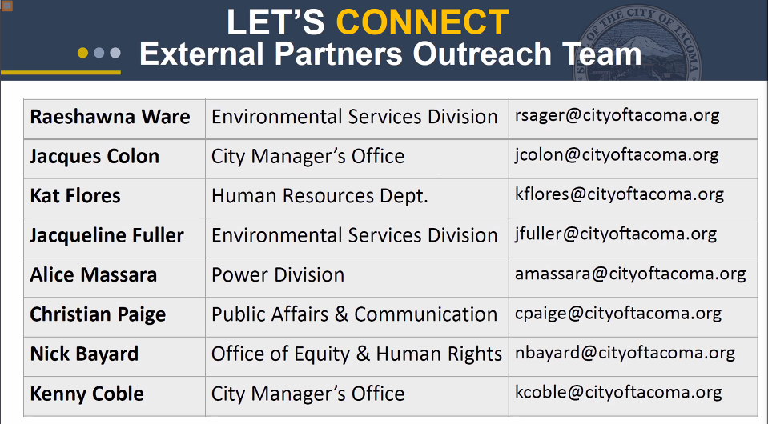
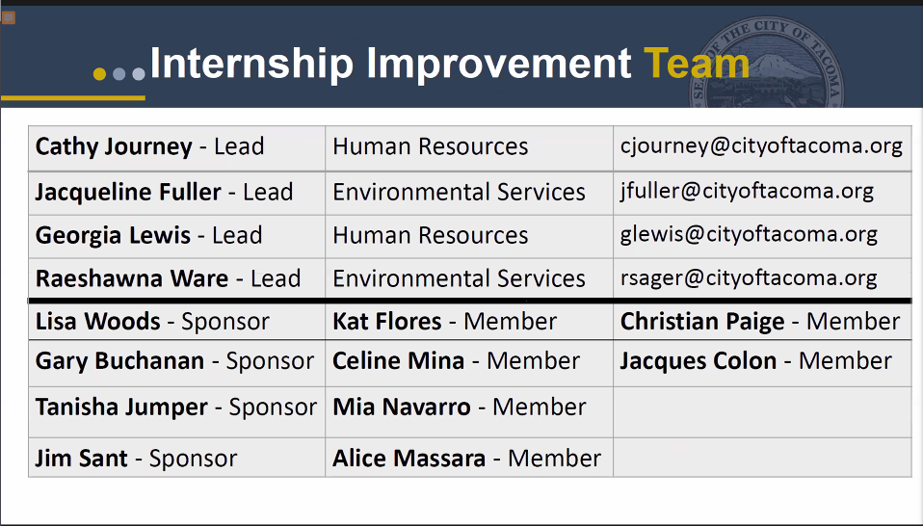

The Child Care Crisis: A Task for Us All - Courtney Nolen-Viducich & Katie Kaiser, Child Care Resources
- Child Care Resources improves all children’s access to high quality learning experiences so that they thrive in their early learning environments. They also work to identify and address racism in these environments.
- What Child Care Resources does
  - Provide early learning info, early learning referrals, and financial assistance to families of all backgrounds
  - Have a statewide call center and give their name and ZIP to get help in finding a family childcare provider within their area.
  - Play & Learn support groups. Provide support to neighbors, friends, and family members-provided care
  - Provide 1:1 coaching and training for childcare providers. Have done so with over 25,000 providers in King and Pierce county. Even during COVID-19 they are working remotely to provide this coaching
  - Advocate for the families and providers they serve so the needs of the children are prioritized.
- Impact of COVID-19 on Families and Child Care
  - COVID-19 has impacted the landscape of childcare in Pierce County. 14% of all childcare providers closed, and 31% of centers have closed in Pierce County whether temporarily or permanently. These are small businesses with tight margins. Drops in enrollment during the pandemic, need for smaller class ratios, and higher costs of supplies and PPE have contributed to these closings.
  - Child Care Resources in partnership with Pierce County Human Services Department and City of Tacoma is distributing $3.5 million in CARES Act child care subsidies to support 783 children from families of essential workers or those whose income, hours, or access to childcare was impacted by COVID-19.
  - CCR saw an uptick in Pierce families calling looking for childcare, especially for school age children.
- The Ask
  - Want to raise awareness of the COVID-19 impact on childcare and the results with families. Will be sending out flyers with the info for their Call Center.
  - Encouraging employers to consider offering financial support for your employees needing childcare. If this is not an option, a partnership with Child Care Resources can be an option. CCR can provide hands-on support in helping them find childcare providers that work for their family
- Contact: Courtney Nolen-Viducich at Nolen-Viducich@childcare.org & Katie Kaiser at kaiser@childcare.org

Organizational Structures Report Out – Dr. Cindy Caldwell
- Organizational Structures group is about bring DEAI to the organizations that are part of the task force. Have already created a leicon, resource guide, assessment tool, and are currently working on a summit for January – April. Have four different sub-groups within this committee
  - People
  - Policy
  - Practice (DEI on the Ground)
  - Promotions
- Would love to have more people in the group, especially those willing to take leadership of some projects!

Outreach Report Out – Ana Owens
- Outreach Committee works to identify and implement ways for people to connect across the Pierce County community. Are calling 2021 the year of resiliency
- Goals and projects for next year:
  - Have unified intake framework for Pierce providers
  - Working with diversequalusion
  - Working on community-focused events for 2021

People & Providers Report Out – Jeff Wolff
- People & Providers Committee centered on taking a human approach toward both community and providers. Raising awareness on services and helping providers by leveraging partnerships or building better tools.
- Goals & projects:
  - Speakers bureau for people who have experienced homelessness to give them a voice and toolkit to build resiliency. Will eventually expand to other topics as well
  - Pandemic Pods: alternative learning and childcare during COVID-19. Looking to partner with local organizations
  - Jeff Dade is leading an un-siloing effort of Pierce County to help service providers connect with each other
  - Phyllis from Career Connect WA is starting a sub-work group to start a cross-county collab on raising awareness on different career paths.

L.O.O.P. & Lobby Breakout Rooms
- Before COVID-19, we would have a whole task force meeting and then break off into small groups to work on committee projects, do the actual work of the task force. This gave every member voice and the opportunity to contribute.
- We want to get back to this meeting format, so we will be starting break off rooms at every PCCETF monthly meeting. If you don’t have a group, you can stay in the “Lobby” and learn more about each group as well as the entirety of the Task Force.

Reminders
- Next meeting is Wednesday, December 2nd at 9am.

Organizational Structures Oct 2020 Meeting
Meeting called by the Community Engagement Task Force.
Date: October 15, 2020
Time: 10:00 am – 11:00 am
Location: Zoom Meeting
Attendees: Dr Cindy Caldwell, Lawrence Garrett, Leah Ford, Amita Lonial, Jaime Prothro, Korbett Mosesly, Rachael Pease, Tunisia Price, Shondea Chapman, Stasea Stewart, Larry Leveen, Karissa Thompson, Ana Owens, Julianna Flanders, Sarah C, Tamar Jackson, Elise Bodell

Subcommittee Report Outs
People Sub-group - Amita Lonial
- Team Members: Karissa, Tunisia, Will, Amita
- Overview of group: Showing how people are the culture of the company. How to be inclusive in workplace discussions.
- On every other week meeting schedule planning out presentation in January
- Will be sharing out how people in your organization equate with the culture of your crew. Tunisia will be sharing out some of the things learned about how to use and analyze data.
- Have breakout rooms and give some sort of exercise to take back to their orgs at the end of the presentation
- Discussed developing a tool kit so that people will have resources/tools like what they will be presenting.
- Next meeting: October 28 at 3:00 pm – 3:30pm (every other Wednesday)
- To join the group email Karissa at kthompson@redcanoecu.com
Policy Sub-group – Korbett Mosesly
- Team Members: Stasea, Larry, Korbett
- Overview of group: Addressing DEI questions from a policy standpoint. The written kinds of things that structure an organization and the culture that staff respond to.
- Haven’t gotten together since the last meeting. Did recommend leveraging the Community of Practice meeting.
- Have had several conversations on mentorship, meeting with Reginald at Pierce Transit
- Need to set a regular meeting schedule.
- To join the group email Korbett at kmosesly@mdc-hope.org
Practice Sub-group – Cindy Caldwell
- Team Members: Cindy, Mike Wilson, Elise
- Overview of group: This group different from policy in that it should talk about how policy can be different from what is put in place on the ground. Practical applications
- Revisited some concepts that they had already talked about with the whole group – about how some policy affects marginalized groups more than others (i.e. rule against sleeping in a library).
- Do not have another meeting scheduled yet
- Looking for additional team members to join
- Could invite people to share their personal experiences from their work and organizations as a part of the presentation
- Could have practice and policy meet together to loop both presentations together?
- To join the group email Cindy at DrCindy@DEIManagement.net
Promotion Sub-group – Lawrence Garrett
- Team Members: Rachel, Jaime, Lawrence
- Overview of the Group: Team is going to highlight organizations who are willing to document and share their progress/successes. Hoping to accomplish 3 things:
- Establish a compass of “North” for organizations,
- Give a real story of real experiences and people.
- Show how to partner and get started
- Will share what they are doing this well, and their difficulties. Ideally a place that has 10+ or 20+ employees
- Would like to identify 5 different types of organizations to highlight:
  - Government: Metro Parks
  - Private: ?
    - Tamar will reach out to BCRA for Private sector
  - School: ?
    - Doesn’t just mean K-12, can also be institution
  - Non-profit: ?
  - Religious: ?
    - Associated Ministries potentially for the Religious representation?
    - Presbyterian denomination?
- To join the group email Lawrence at lawrence@828flow.com
Share out at the next meeting
- As a team, the Org Structures Leadership is working on not speaking on behalf of the team as much and to try and give speaking time to members of the group.
- Report outs for the next monthly PCCETF meeting
  - 5 minutes- What is the organizational structures group?
  - 5 minutes – What are we working on as a group?
  - At a separate time, could give an update about your organization and its progress
  - Does not need to be a large or impressive spiel
- Karissa Thompson will give the Org Structures report out at the November 2020 meeting
- Tunisia Price will give the Org Structures report out at the December 2020 meeting
Neighborhood Councils
- City of Tacoma has Neighborhood Councils (501c3) set up. Broken up in 9 different sectors in Tacoma, which show representation in governance. When City Council members look to get the word out they often work with these councils, and often will work vice versa as well.
- How do we as a team, partner with the Neighborhood Councils? Can we be more visible in some of our neighborhood council meetings, and position those with a DEI perspective, background, or lens within them to create more DEI policy within the city?

Action Items/Highlights
- Going forward the Org Structures Leadership team will be working towards having group members report out at the Monthly Meeting to greater represent the group. Karissa will report out in November and Tunisia will report out in December
- Each subgroup presenting in the DEI series will plan their next meetings and continue working on their presentations
- All subgroups are still looking for additional team members, please reach out to team leaders or members to join their group and contribute to the presentation.

People & Providers Oct 2020 Meeting
Meeting called by the Community Engagement Task Force.
Date: October 29, 2020
Time: 11:00 am – 12:00 pm
Location: Zoom Meeting
Attendees: Lynn Willis, Emily Huff, Amanda Walkingstick, Yvette Wilson, Jeff Wolff, Gerrit Nyland, Joyce Glavish, Julianna Flanders, Leah Ford, Shellie Willis, Devon Isakson, Leandra S, Elvin Bucu

Group Changes in Peoples Group
Leadership
- Jeff Dade is back on leadership team, and is now with Forterra
- Yvette Wilson is now on leadership team for Peoples group. Will be taking over Jeff’s role.
- Will be delegating roles through the group and giving everyone different roles. Jeff will be a floater working on the Task Force behind the scenes. But will still be involved with Peoples group.
New changes, Task Force Meeting, Membership
- The next meeting (November 10) be having breakout groups at the end of the meeting. Everyone part of People’s will break off and have 30-45 min to talk about what’s going on. Taking a more intentional approach to onboarding.
- Working to develop what it means to be a member of the PCCETF and improve the Facebook group.

Pandemic Pods and Care Village
- Pandemic Pods set up to help parents in addressing the new childcare and homework assistance needs created by COVID-19
- Have been able to find a networking program similar to the one discuss called Care Village.
- Will be taking it in a new direction. Will first set up a “practice pod” with local parents and connect them to the Care Village site. Take into organizations where people are already looking for assistance.
  - Create own pods by grouping parents in groups of 5. Ideally parents who work Monday through Friday. One parent will take Monday, and work the rest of the week, Parent Two will take Tuesday, etc.
  - Help so that parents don’t have to pay for childcare. If we can get employers involved, we can possibly get them onboard to support the new work schedule. Possibly work out a different wage for their babysitting day so that there are no lost wages during this time.
    - Possibly add in a weekend pod with a group of 3
- Was there any surveying done to determine whether this was a need in the community?
  - Have talked to parents on an individual basis in different groups, and have seen a need. Have held off on a survey as people have said they are tired of surveys with nothing to back it up. Have partnered with many organizations in the area who focus specifically on childcare to influence which direction to go in, and the type of needs in our area. Using the results of these organizations surveys as week
  - We also know that these “pods” are happening on a neighborhood level with friends and family, but are wanting to see if we can expand it to a regional level.
  - Joyce has done some work with Childcare Aware, who may have some resources if this evolves. Can have resources to share with people on how to take care of other people’s children.
- Does the Care Village website have a way to screen people?
  - We are partnering with local programs to establish guidelines on what “host families” need to be a part of the program. The biggest need is in BIPOC and low-income individuals/households
  - Working on matching people on a referral basis
- Is there an assessment in peoples tolerance/exposures/behaviors?
  - This is something that will be developed. This process is brand new as of last week, but this on the checklist of things to go through. Currently just in the brainstorming page
- Trust is a big factor specifically in the communities that are being targeted. How are we going to meet these needs to make people more comfortable in sending their children to these houses?
  - Will be partnering with local organizations to ask about this need when doing their intake. This program is more of a referral type thing than just directing people to the website. i.e. helping people you work with or within the neighborhood that you know and sending people to them rather than just to visit the website. More of an intentional, warm handoff.
  - Closed referral system that works off emails.
  - Keeping it as simple as possible at the moment, possibly not accepting children with allergies or special needs just to get this program off the ground. Then working later to develop ways to include these groups
- What about questions about the home that the children that was being brought to? How hard would it be to set this up with MDC, and we set up babysitting within an establishment equipped for childcare and not in someone’s home? A parent would watch the children in a separate location?
  - Would take collaboration between different organizations to find a neutral space but could potentially find a way to make it happen.
  - Arlington Apartments may be a viable space for a neutral space for the program
  - If there’s a need for locations, it might be worth looking into using different churches. Many have classrooms, kitchens, and other spaces

Speaker’s Bureau
- 3 new members are joining the Peoples group specifically because of this project
- Are putting together a group of people with lived experience and expertise to share on a subject. We are beginning on the subject of homelessness. Amanda will be sharing first to allow us to work out the kinks and develop a template. Will assign each speaker a “assistant” to help them develop their story, a short bio, a long bio, and help them to practice public speaking. Goal will be to help them build a toolkit in exchange for them sharing their expertise and story
- Meeting every 2 weeks to build on this and develop documents putting this together.
- Would love to have more people join in and develop
  - Need someone to help figure out how to get speakers out to organizations, advertise a little bit
  - Need someone to help figure out what documents are missing
  - Next meeting is Tues, Nov 17 at 1:00
- Current Progress:
  - Speakers Assistant Questionnaire: Prompt speaker to think about their story and get them to organize their story. This can then be taken to fine tune the pieces that will be needed
  - Speakers Toolbox: Allow them to use this experience as life experience. Includes building a skill-based resume, giving opportunities to network with other organizations where they can speak, short and long bio, professional headshot, letters of recommendation, and eventually more.
  - Advertising to Organizations: Have been brainstorming. Have 3 ideas on this that are being worked on
- The hope is to allow this experience to have speakers go into different fields.
- What do we want the organizations to do?
  - Goal is to give speakers a voice. But the goal for organizations is to bring providers and those seeking services together, to rebuild trust. Ensure that both parties are on the same page to continue innovating services. Will be a way of reintroducing the community to the community.
- A speaker’s bureau is a thing that a lot of coalitions have. Gerrit sees this as being useful in many different areas and is looking to set up something like this to be a part of the Coalition to End Homelessness.
- Joyce also sees this as an opportunity to use the bureau as a resource to get a quick feedback from members of different communities for outreach efforts (i.e. setting up a new shelter, and getting feedback from someone with a background of homelessness on the development of rules for the program).
- Could look into having the hosting/listening organization providing the compensation to the Speakers (i.e. we recommend that you offer a speaking fee of $X).
  - Elvin and Leandra are interested in joining the program and working on this conversation
- Can also put it out there that organizations can hire the speakers after the speaking to get their valuable expertise on their programs and initiatives for the long term.

Action Items
- Yvette, Gerrit, and Devon will be joining the subcommittee developing the Speaker’s Bureau

